An Investigation into Theoretical Stability

**By Jordan Stidham**

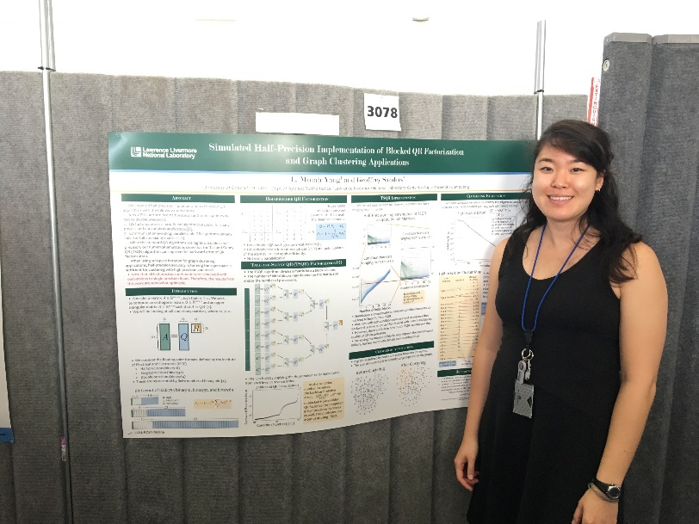

*Lucia Minah Yang, a doctoral student, recently completed a research experience using applied mathematics to investigate computational methods to advance technology and solve national security issues. Her research experience was made possible by the National Science Foundation Mathematical Sciences Graduate Internship Program. (Photo courtesy of Barry Goldman)*

As a child, Lucia Minah Yang grew up in a supportive environment. Her parents prioritized a challenging education throughout her life, and her teachers recognized her aptitude in mathematics at a very young age. Yang’s teachers encouraged and emboldened her to learn materials beyond what was being presented in class.

Fast forward several years and Yang is now a third-year doctoral student in applied mathematics at the University of Colorado Boulder.

“I wanted to study mathematics, not just for academic endeavor, but also with the potential that my research could positively impact others,” Yang said. The National Science Foundation (NSF) Mathematical Sciences Graduate Internship (MSGI) Program was the perfect opportunity for her.

The program provides research opportunities for mathematical sciences doctoral students to participate in internships at national laboratories, industries and other facilities. NSF MSGI seeks to provide hands-on experience for the use of mathematics in a nonacademic setting.

For her appointment, Yang contributed research to the Variable Precision Computing (VPC) project in the Center for Applied Scientific Computing at the Lawrence Livermore National Laboratory in Livermore, California. The VPC project is comprised of applied mathematicians, computer scientists and electrical engineers collaborating together to reevaluate and redesign computational techniques critical to enhancing national security.

“Being a part of such a large and long-term project was a new experience for me. It showed me the inner workings of a collaborative environment for technical research outside of academia,” Yang said.

Yang and her mentor, Geoffrey Sanders, Ph.D., ­­­explored various computational methods, which could eventually led to the general public having access to more advanced technology. The purpose of her summer research was making computations run faster, more efficiently and more accurately.

Specifically, Yang investigated whether certain methods could increase stability in QR factorization by using half-precision arithmetic. QR factorization is a basic linear algebra tool useful for many physics and data analysis applications. Standard QR algorithms are highly unstable in half-precision, meaning the results may lead to an unacceptable amount of error. The numerical algorithm simulations Yang and the team conducted can reduce errors in QR factorization and produce more accurate results.

The research opportunity allowed Yang to understand the importance of more theoretical components of mathematical research. Other key takeaways from her experience included a desire to seek collaborations outside of her department, to participate in interdisciplinary scientific organizations and to be more open to opportunities outside of her direct path.

“The experience allowed me to focus on research and prepare for the remaining years of my graduate program,” Yang said. “I really appreciate how this opportunity has diversified my research interests. I will definitely be recommending this program to other graduate students.”

Upon completion of the program, Yang returned to the University of Colorado Boulder to complete her doctoral degree. She actively contributes to the Association for Women in Mathematics chapter at her university and the Society for Industrial and Applied Mathematics.

The NSF MSGI Program is funded by NSF and administered through the U.S. Department of Energy’s (DOE) Oak Ridge Institute for Science and Education (ORISE). ORISE is managed for DOE by ORAU.